**awk command:-**

AWK is a scripting language in itself used for Text related operations , manipulating data and generating reports.

It required no compiling and also allows users to use variables , numeric fuctions , strings and logical operators.

AWK is abbreviated from the names of it's developers : Aho , Weinberger and Kernighan

AWK Operations :

- Scanning a file line by line

- Splits each input line into fields based on field seprator.

- Compare input line/fields to pattern

- Perform some kind of actions on matched or compared lines.

Usages:

- Transform data files

- Helpful in generating meaningful reports.

AWK syntax :

- awk [options] 'selection criteria{action}' <filename>

Some of the commonly used [options] :

-F : To specify a field separator

-f : Specify the file that contains scripting

-v : To assign variable

Built-In Variables

- NF : It gives number of fields in the data.

- NR : It gives number of current record.

- FS and OFS : Field Separator and Output Field Separator.

- RS and ORS : Separates the records and Output Record Separator.

Use Cases of AWK commands :

1. To Print a column of a file

awk 'print $x' <filename>

awk '{print}' employee.txt

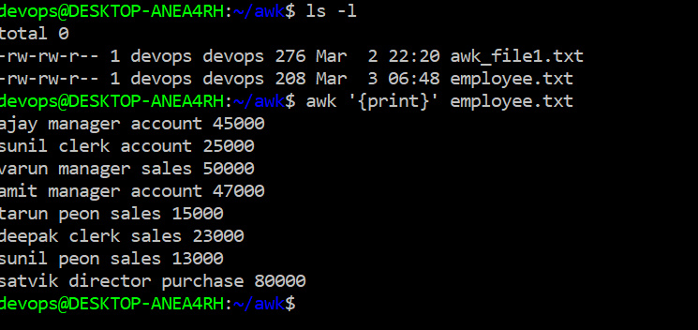

2. Use regular expression with awk

awk '/regex/ {print $x}' <filename>

awk '/manager/ {print}' employee.txt

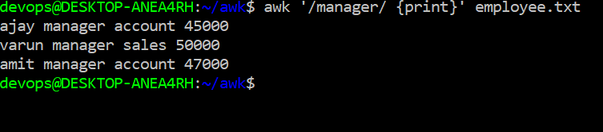

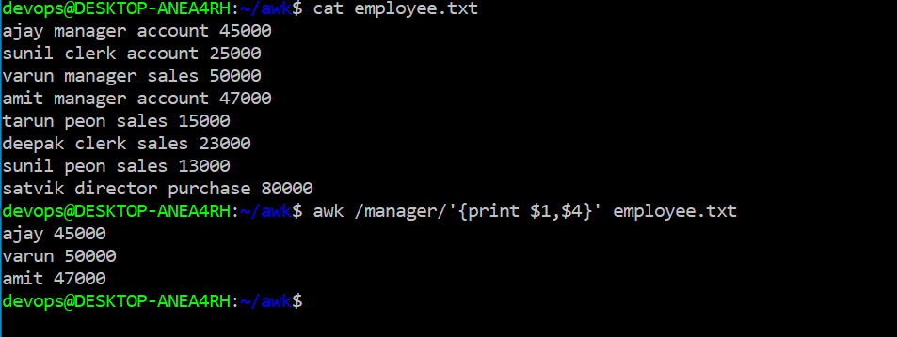

3. Use relational expression with awk

awk '$a ~/regex/ {print $x}' <filename>

4. Use negation for exact opposite result

awk '$a !~/regex/ {print $x}' <filename>

5. To use range pattern with awk

awk '/regex1/,/regex2/ {print $x}' <filename>

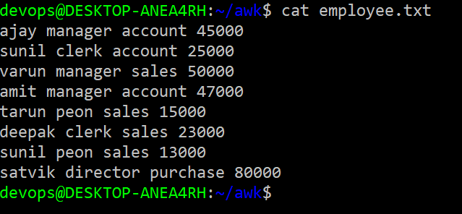

Output:

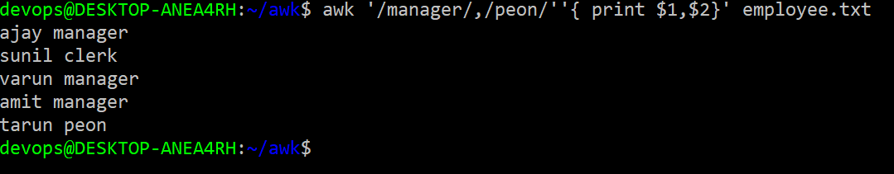

Assignments :

Create a use case to combine pattern using logical operator.

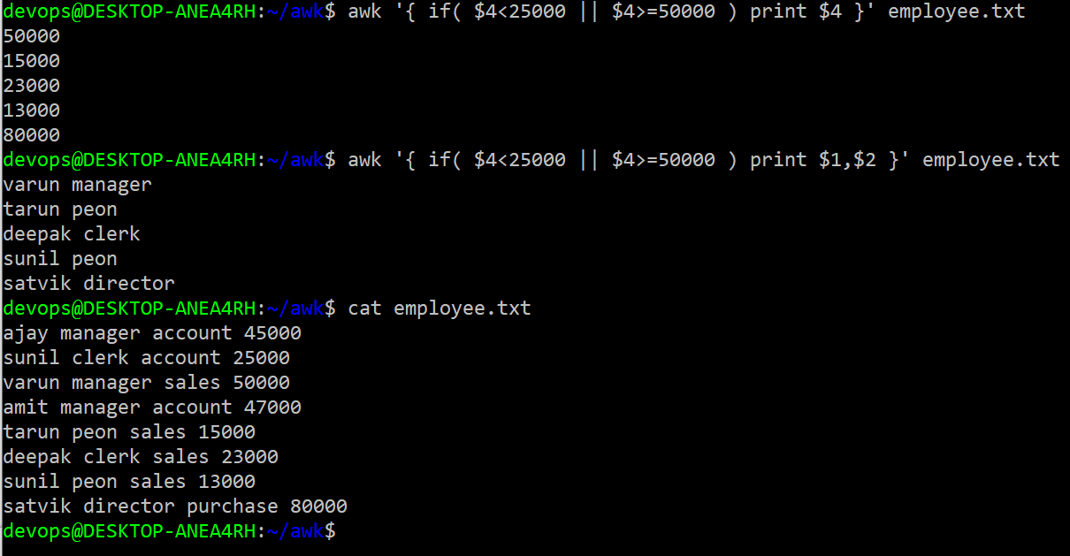

Create a use case using built-in variable of awk command.

4 X use cases using built in variables.

**1.** awk '{print NR,$0}' employee.txt

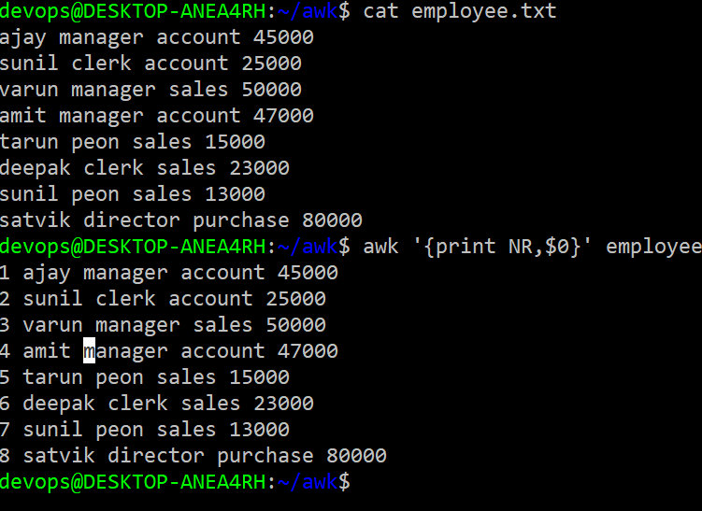

2.awk '{print $1,$NF}' employee.txt

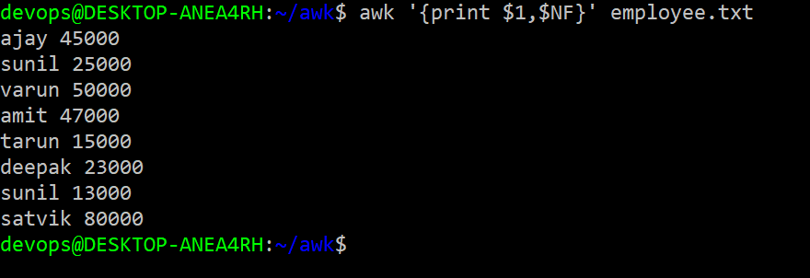

3.awk 'OFS=”/”{print $1,$2}' employee.txt

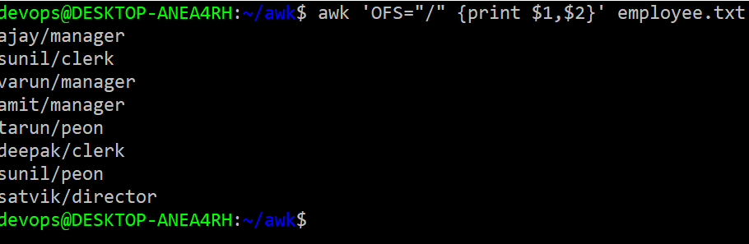

4.awk ‘BEGAIN=”,”{print} employee.txt

